Module 5

Assignment 5.2
Course: CSD340-340A Web Development with HTML
Prepared By: Mirach Erkol
Date of Report: 2/8/2025

https://github.com/Mikey5007/CSD340.git

5.2 Assignment: Front End Style Guide

Color Palette
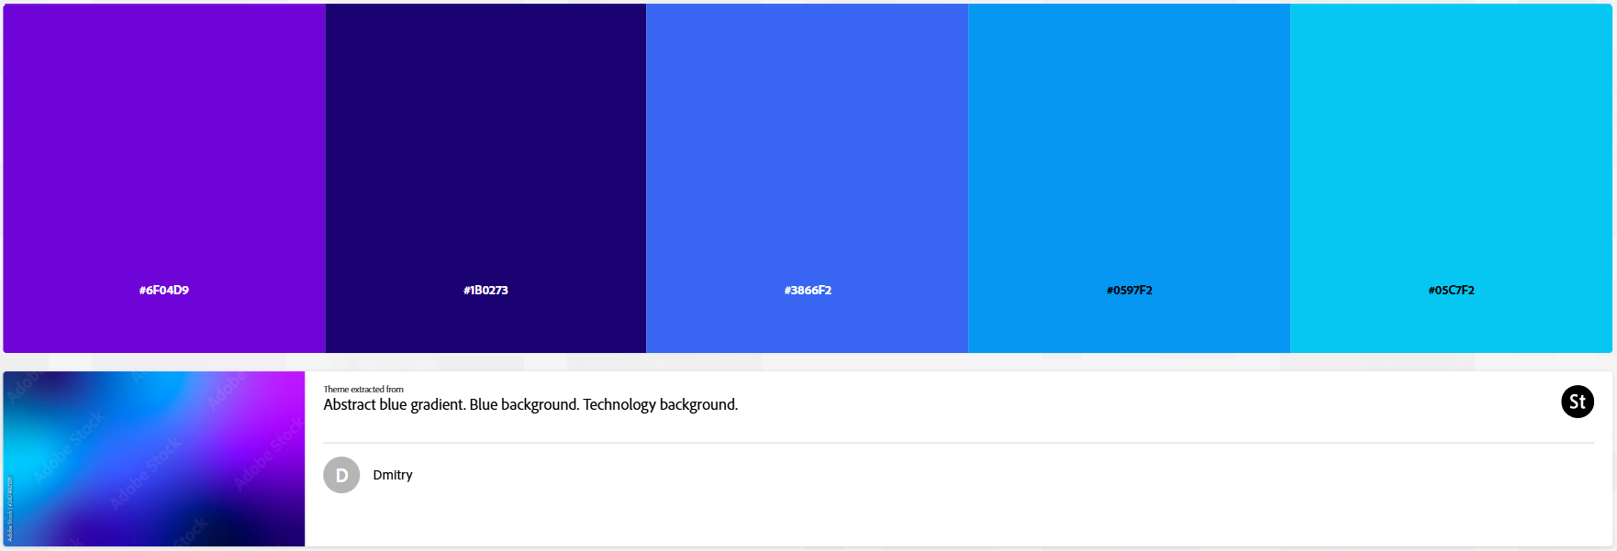

Style Guide

1. Overview
Site Name: Brittany’s Bio
Purpose:
A simple, personal website that tells Brittany’s story through visuals, short written sections, and clear navigation.
Tone & Feel:
- Personal and approachable
- Clean and modern
- Calm, creative, and friendly
Design Focus:
- Purple as the dominant color
- Blue tones used as supporting accents
- Simple layouts that prioritize content and images
2. Color Palette
Primary Brand Colors (Purples)
These colors establish the main identity of the site.
- Electric Purple — #6F04D9
- Used for:
  - Main headings (H1, H2)
  - Buttons and call-to-action elements
  - Key highlights
- Deep Indigo — #1B0273
- Used for:
  - Page titles
  - Navigation emphasis
  - High-contrast text on light backgrounds
Secondary Accent Colors (Blues)
Used to support the primary purple tones without overpowering them.
- Royal Blue — #3866F2
- Used for:
  - Section dividers
  - Secondary headings
  - Visual accents
- Bright Sky Blue — #0597F2
- Used for:
  - Hover states
  - Icons
  - Interactive elements
- Cyan Blue — #05C7F2
- Used for:
  - Decorative accents
  - Subtle highlights
  - Balance within the color scheme
Neutral Colors
Used for layout structure and readability.
- White — #FFFFFF
- Used for:
  - Content cards
  - Image containers
  - Text backgrounds
- Light Gray Background — #F2F3F6
- Used for:
  - Overall page background
- Soft Gray — #D2D6DD
- Used for:
  - Footer background
  - Navigation sections
  - Divider bands
- Dark Gray Text — #1F1F1F
- Primary body text color
- Muted Gray Text — #6E6E6E
- Secondary or descriptive text
3. Typography
Font Stack:
Arial, Helvetica, sans-serif
This font choice keeps the site:
- Accessible
- Easy to read
- Consistent across browsers
Text Hierarchy
- H1 – Page Titles
  - Bold
  - Centered
  - Color: Deep Indigo (#1B0273)
- H2 – Section Titles
  - Bold
  - Centered
  - Color: Electric Purple (#6F04D9)
- H3 – Subsections
  - Semi-bold
  - Color: Royal Blue (#3866F2)
- Body Text
  - Regular weight
  - Color: Dark Gray (#1F1F1F)
  - Comfortable line spacing for readability
5. Page-Specific Layouts
Landing Page
- Site title centered at the top
- Large hero image
- Navigation section below the image with:
  - About link
  - Hobbies link
- Footer with social icons and external links
About Page
- Page title at top
- Portrait image centered
- About section with minimum 250 words
- Goals and Accomplishments section below the bio
- Footer consistent with landing page
Hobbies Page
- Page title at top
- Vertical list of hobby sections
- Each hobby includes:
  - Image on the left
  - Section title and short description on the right
- Consistent spacing between hobby items
6. Components
Images
- Minimum of 7 images total
- Consistent sizing per page
Buttons & Links
- Purple as the default color
- Blue accents on hover
Footer
- Soft gray background
- Centered social media icons
- Includes at least one external website link
7. Accessibility & Usability
- High contrast between text and backgrounds
- Simple navigation structure
- Clear visual hierarchy
- Descriptive alt text on all images

5.2 Assignment: Site Wire Frame
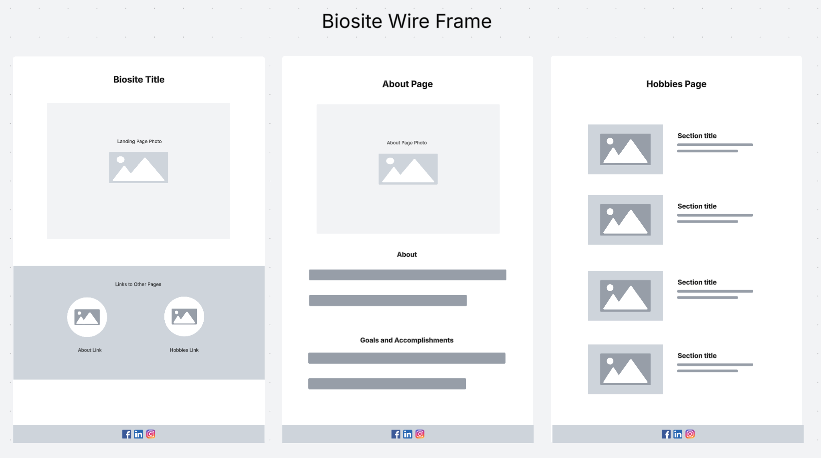

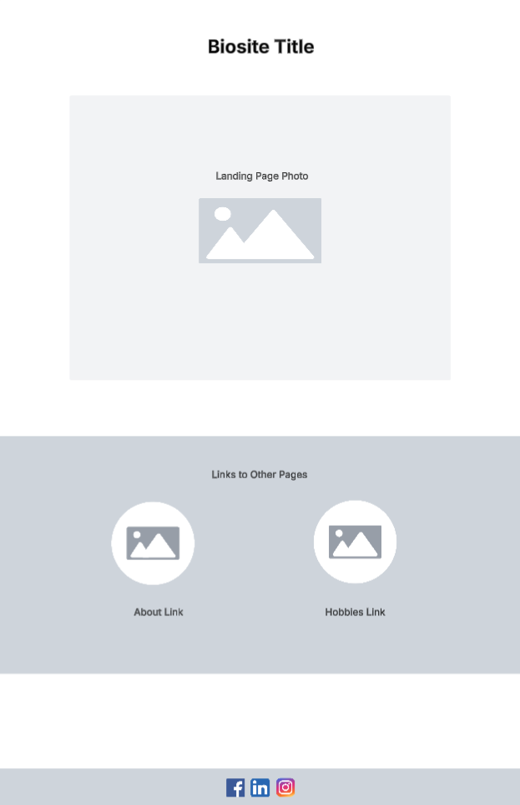
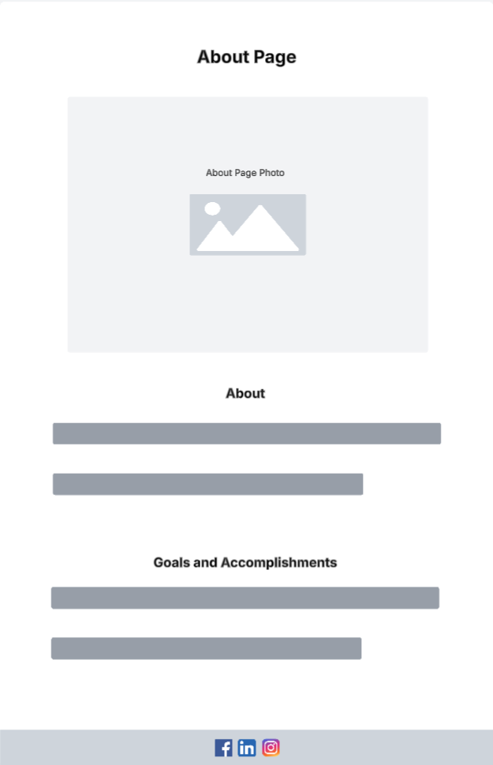
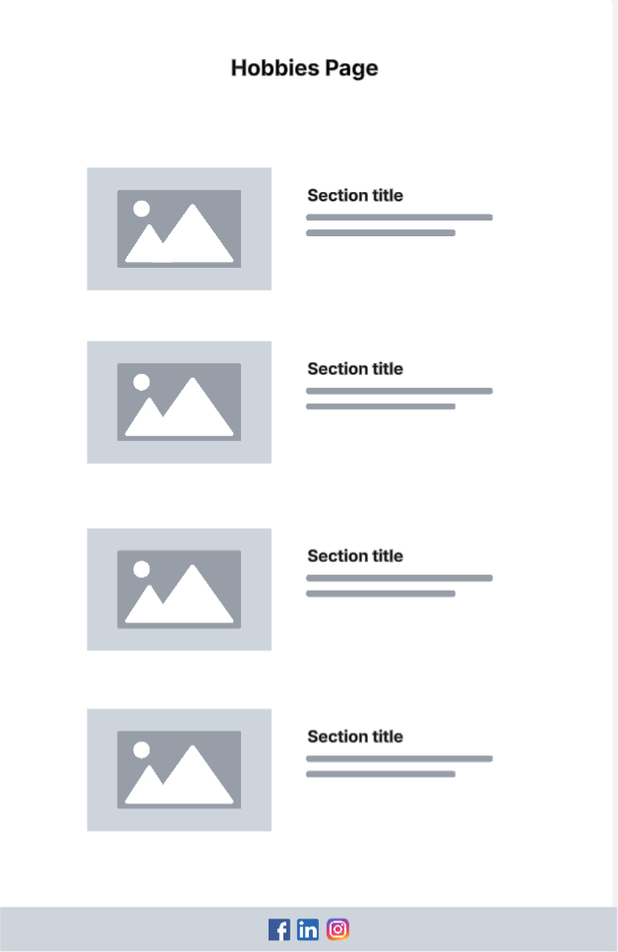
5.2 Assignment: Interview

1. Where were you born and raised?
I was born on January 19, 1990, in the Dallas–Fort Worth area of Texas, and I’ve lived in Texas my whole life.
2. How would you describe your personality?
I’m very outgoing and social. I enjoy being around people, having fun, and making memories with friends and family.
3. What do you do for work?
I work at a car dealership as a lead customer service representative, helping customers and supporting my team.
4. What do you enjoy doing in your free time?
I love spending time with friends and family, playing board games, dancing, singing, and just having a good time.
5. Do you have any hobbies?
Yes, I’m a huge animal lover. I have cats, dogs, rabbits, and snakes, and at one point, I even bred snakes.
6. What role does family play in your life?
Family is very important to me. I enjoy spending time with them and staying connected as much as possible.
7. What are some goals you are working toward?
I want to go to school for cosmetology or beauty training so I can turn my passion for hair and makeup into a career.
8. Why are you interested in cosmetology and beauty?
I enjoy doing makeup and hair, and friends and family often ask me to do theirs, which really motivates me.
9. What accomplishments are you most proud of?
Becoming a homeowner at 28 and making big improvements toward a healthier lifestyle are two things I’m very proud of.
10. What motivates you every day?
My family, my animals, and the goal of building a career doing something I love keep me motivated.

5.2 Assignment: About Brittany

Brittany is a 35-year-old Texas native who was born on January 19, 1990, in the Dallas–Fort Worth area. She is known for her outgoing personality, positive energy, and strong connection to family and friends. Brittany has been married to her husband since she was 18 years old, and although she does not have children, she is a passionate animal lover. Her household includes cats, dogs, rabbits, and snakes, and caring for animals has become one of her favorite hobbies. At one point, she even explored breeding snakes, which reflects her curiosity and dedication to learning new things.
Professionally, Brittany works at a car dealership as a lead customer service representative. In this role, she supports both customers and coworkers, using her strong communication skills and friendly nature to create a positive experience. Outside of work, Brittany enjoys staying active, eating healthier, and continuing to improve her overall lifestyle. She takes pride in the progress she has made toward living a healthier and more balanced life.
One of Brittany’s long-term goals is to pursue formal education in cosmetology or beauty training. She has a natural talent for makeup and hair styling and is frequently asked by friends and family to help with special occasions. Turning this passion into a professional career is something she is excited about and actively working toward. Brittany is also proud of becoming a homeowner at the age of 28, which represents her independence, responsibility, and commitment to building a stable future.

5.2 Assignment: Images

Landing Page:

Hero Image

About Link

Hobbies Link
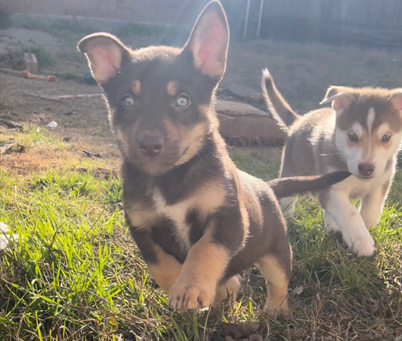

Hobbies Page:

Hobby 1
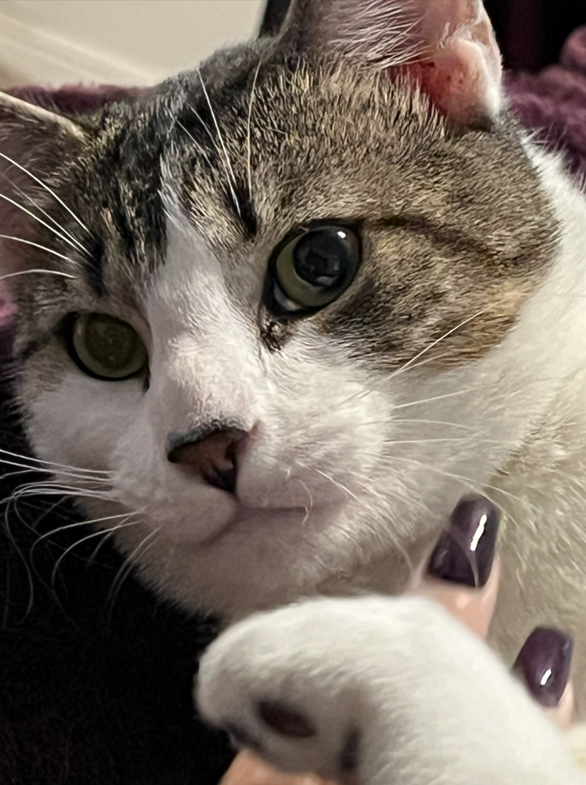

Hobby 2

Hobby 3
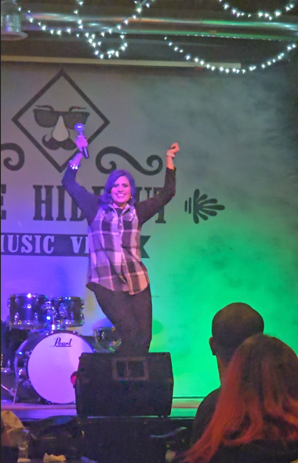

About:
Main Image


